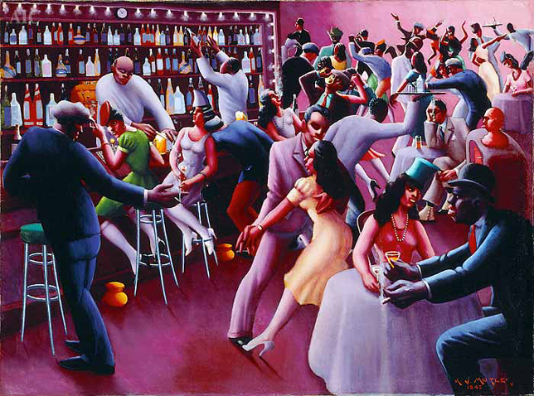
Archibald J. Motley Jr. - Nightlife, 1943

