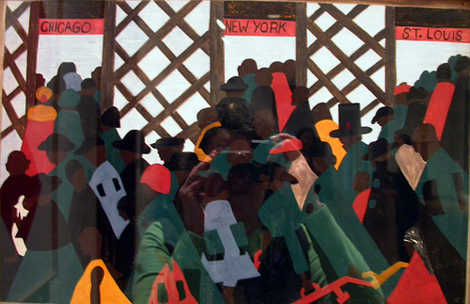

Jacob Lawrence - Migration Series, trains.

